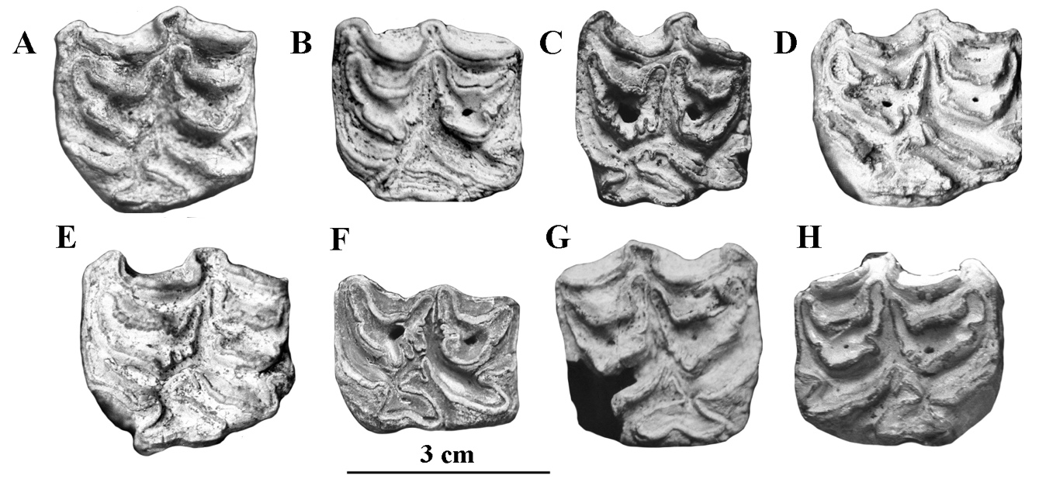

Figure S3. Occlusal views of upper cheek teeth of *E*. cf. *suessenbornensis*. A: IQW S 1964/1182, left P3 or P4; B: IQW Süss. 7189, left P3 or P4; C: IQW Süss. 5617, left P4 or M1; D: IQW Süss. 7222, left P3 or P4; E: IQW Süss. 9230, left P3 or P4; F: IQW Süss. 6584, left P4 or M1; G: IQW Süss. 9264, right P3 or P4; H: IQW Süss. 9260, right P3 or P4.